Transcript of Records |  | 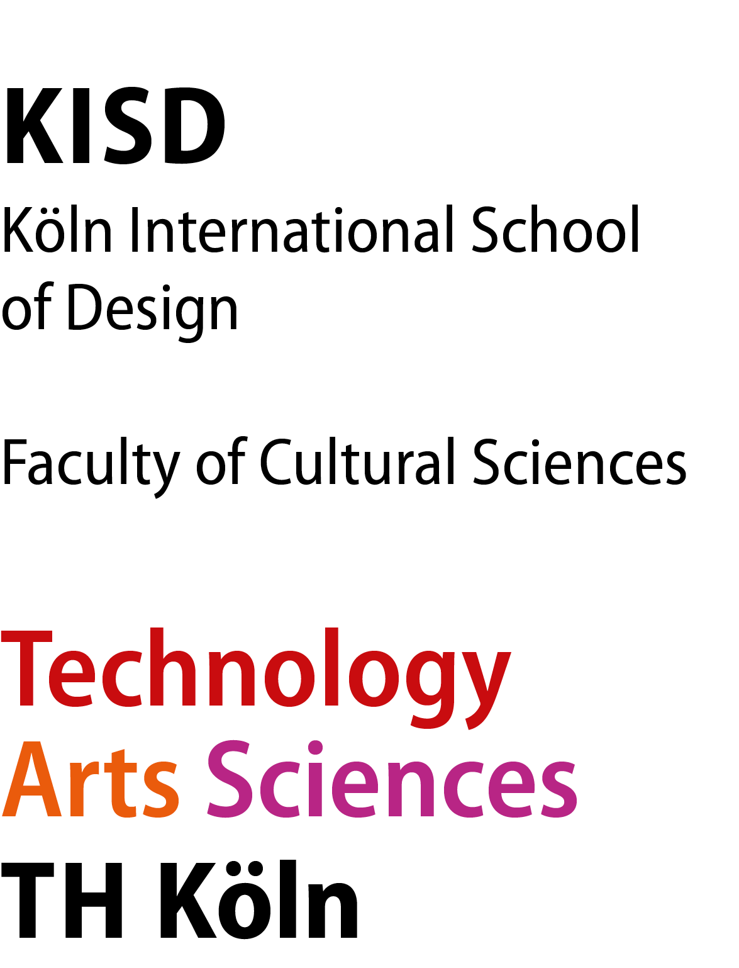
Student
Home University
Current semester @ KISD | Winter Semester 2019/20
Study Program | BA or MA
Study Course
Integrated Studies in Design or
European Studies in Design

We hereby confirm that the above-mentioned student successfully completed the following courses at KISD:

Course Nr. | Title | Type / Workload | Area of Expertise | Lecturer/Signature | Credits | Grade

Total |  | Credits

Cologne, ....................  Cologne, ^{(Date)} | ................................................................................................................ ^{(Signature Angelica Salcines)}

Explanations

Credits / ECTS All students at the Köln International School of Design / TH Köln get credits for their projects, seminars and courses. The European Credit Transfer and Accumulation System (ECTS) was introduced in 1989, within the framework of Erasmus. ECTS is the only credit system which has been successfully tested and used across Europe. ECTS is based on the principle that 60 credits measure the workload of a full-time student during one academic year. The student workload of a full-time study program in Europe amounts in most cases to around 1800 hours per year and in those cases one credit stands for around 30 working hours.

Type / Workload KP Short Term Project (one – two weeks / 60-90 hours)
MP Medium Term Project (half semester / 180 hours)
LP Long Term Project (whole semester / 360 hours)
EO Event Organization (whole semester / 360 hours)
SIP Self-initiated Project (half semester / 180 hours)
IP Intermediate Project (half semester / 180 hours)
ID Intermediate Defense (two weeks / 60 hours)
WS Scientific Seminar (whole semester / 120 hours)
TS Technical Seminar (whole semester / 90 hours)
WE Workshop Introduction (one week / 30 hours)
CO Course (whole semester / 30-60 hours)
AG Working Group (whole semester / 60 hours)
CR Cologne Resources (one week / 30 hours)
MT Mentoring (whole semester / 30-90 hours)
SJ Study Journal (whole semester / 30-90 hours)
PP Proposals (half semester / 180 hours)

Areas of expertise DE Design & Economy
DFM Design for Manufacturing
DK Design Concepts
DTF Design Theory & Research
ECO Ecology & Design
GD Gender & Design
ID Identity & Design
IAD Interaction Design
IF Interface Design
IM Image & Motion
PT Production Technologies
SD Service Design
SoCo Social Constructions
TL Typography & Layout

Grading scheme: 1-1,3 excellent
1,7-2,3 good
2,7-3,3 satisfactory
3,7-4,0 sufficient
4,3-5,0 not sufficient / failed

Other: SoSe summer semester
WiSe winter semester

